| **NAME** | Pratheek.P.Rao |
| --- | --- |
| **REG NO** | 311520104036 |
| **CLASS** | B. E - CSE |
| **EMAIL ID** | pratheekprao@gmail.com |
|  | **ASSIGNMENT - 2** |

| **Task** | Upload the dataset to Cognos Analytics, prepare the data, explore and create Interactive Dashboard, report and Story |
| --- | --- |
| **Problem Statement:-** | |

HR data can be hard to come by, and HR professionals generally lag behind with respect to analytics and data visualization competency. We use the data set to teach HR students how to use and analyze the data in Cognos - a data visualization tool that'seasy to learn.

**Output:-**

**Overall Dashboard**

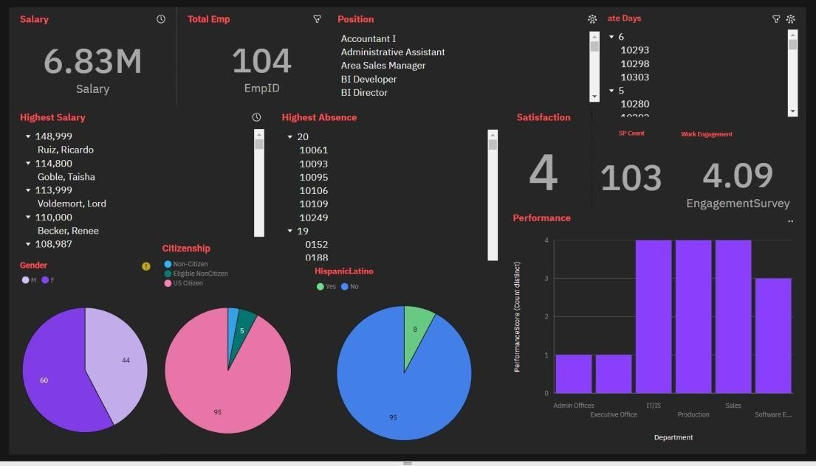

**Female Employees**

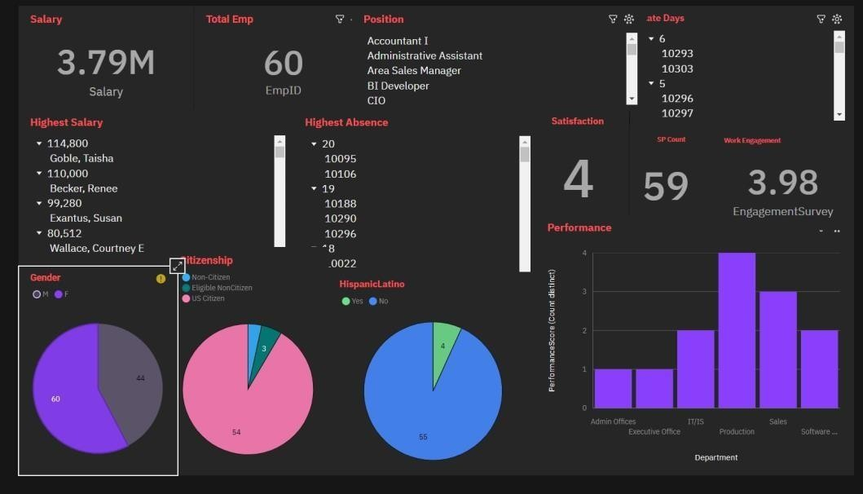

**Male Employees**

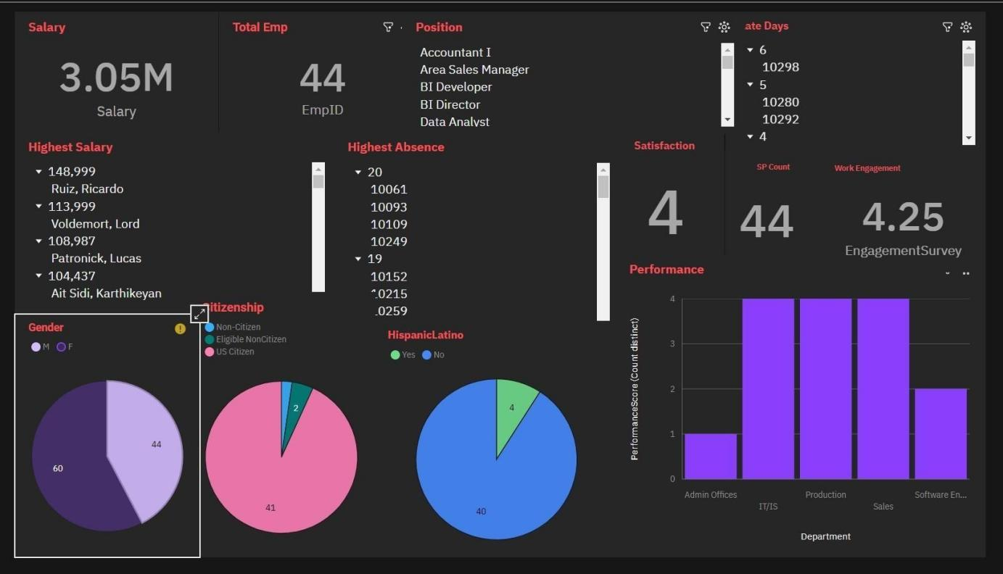

**Data Analyst Employee**

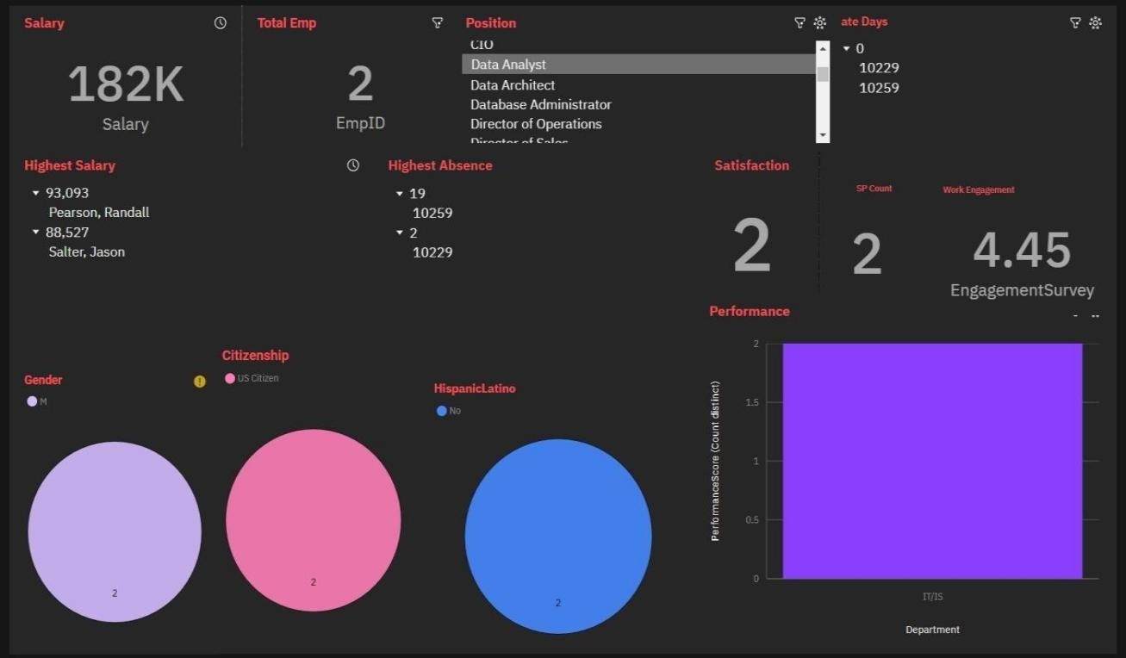

**US Citizen Employees**

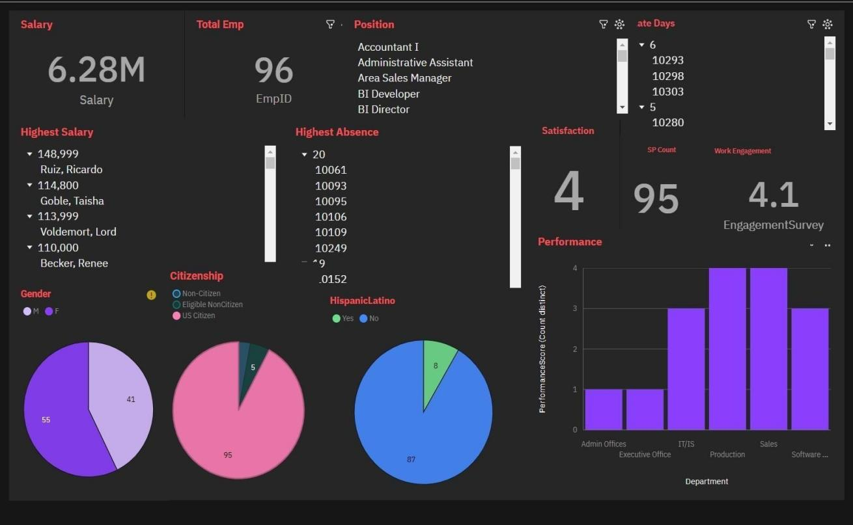

**Search with Marital Staus**

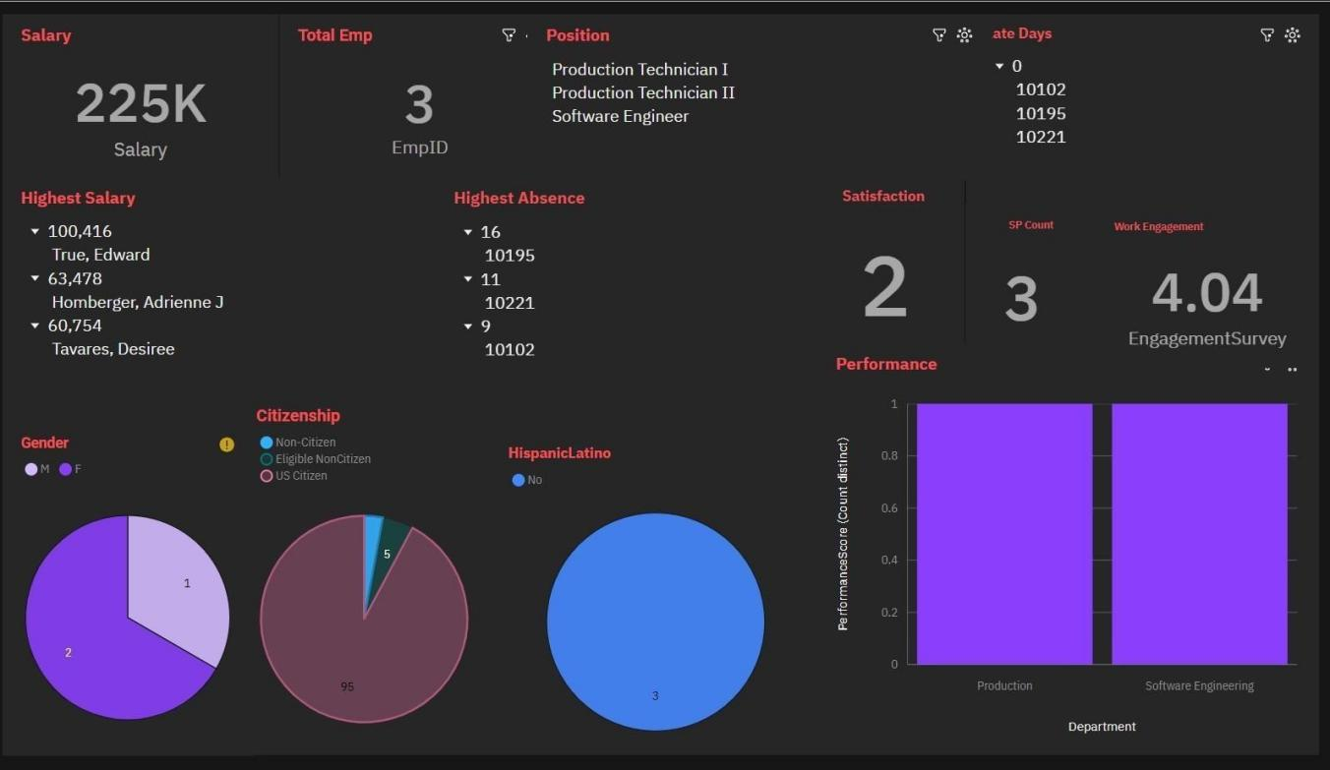

**Eligible Non Citizen Employees**

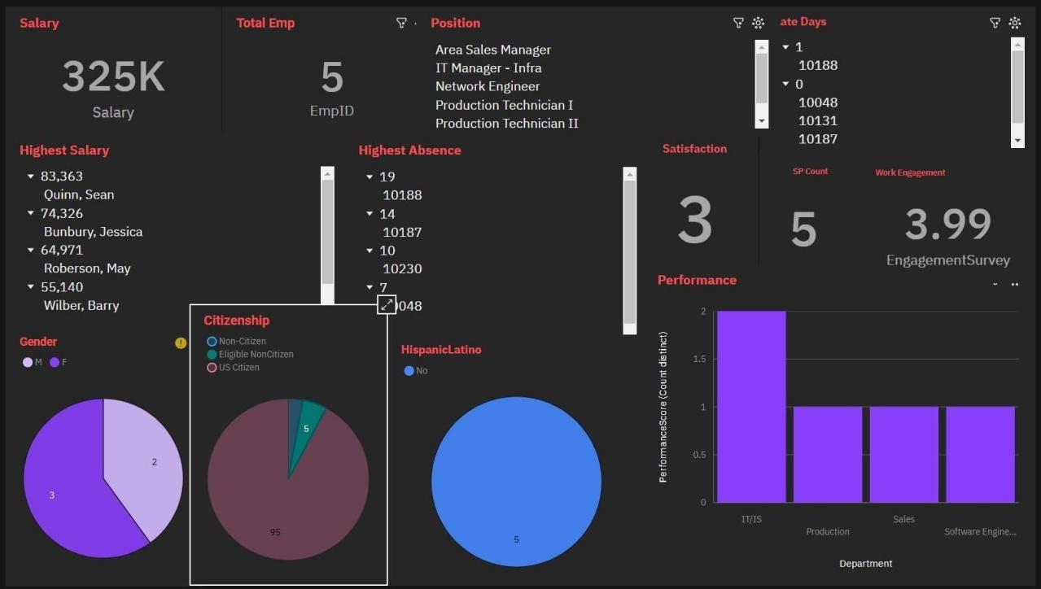

**Search Dashboard**

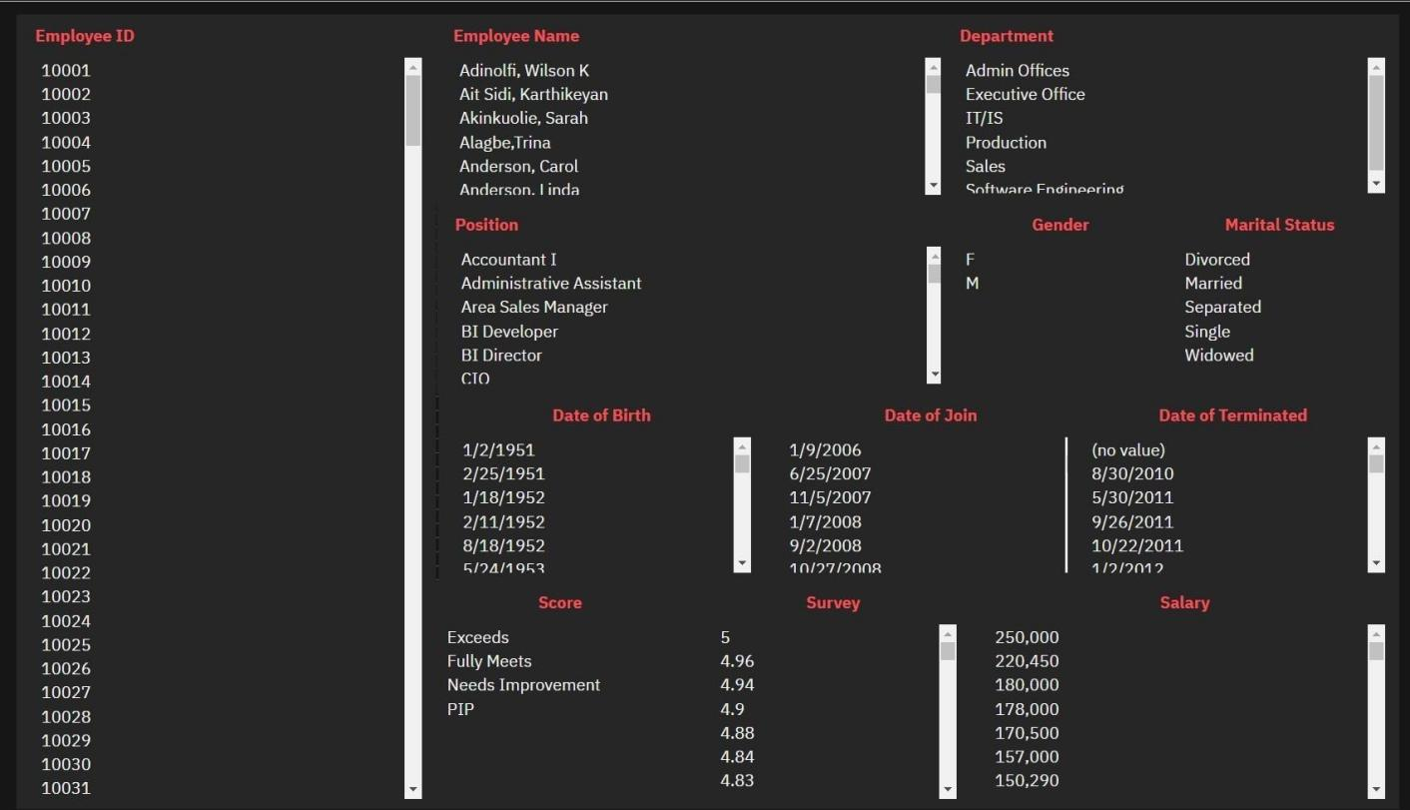

**Search with Employee ID**

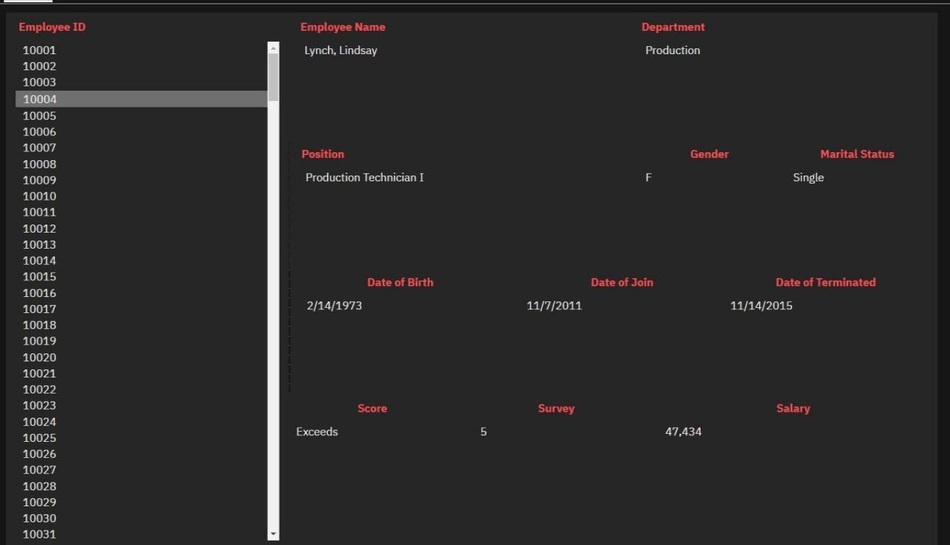

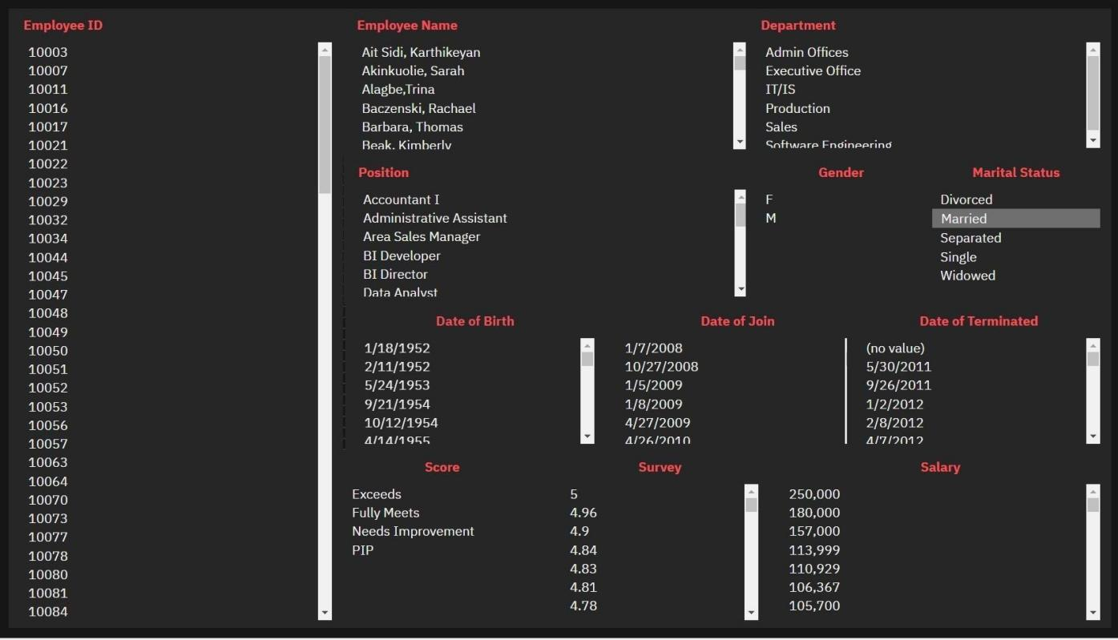

**Search with Performance Score**

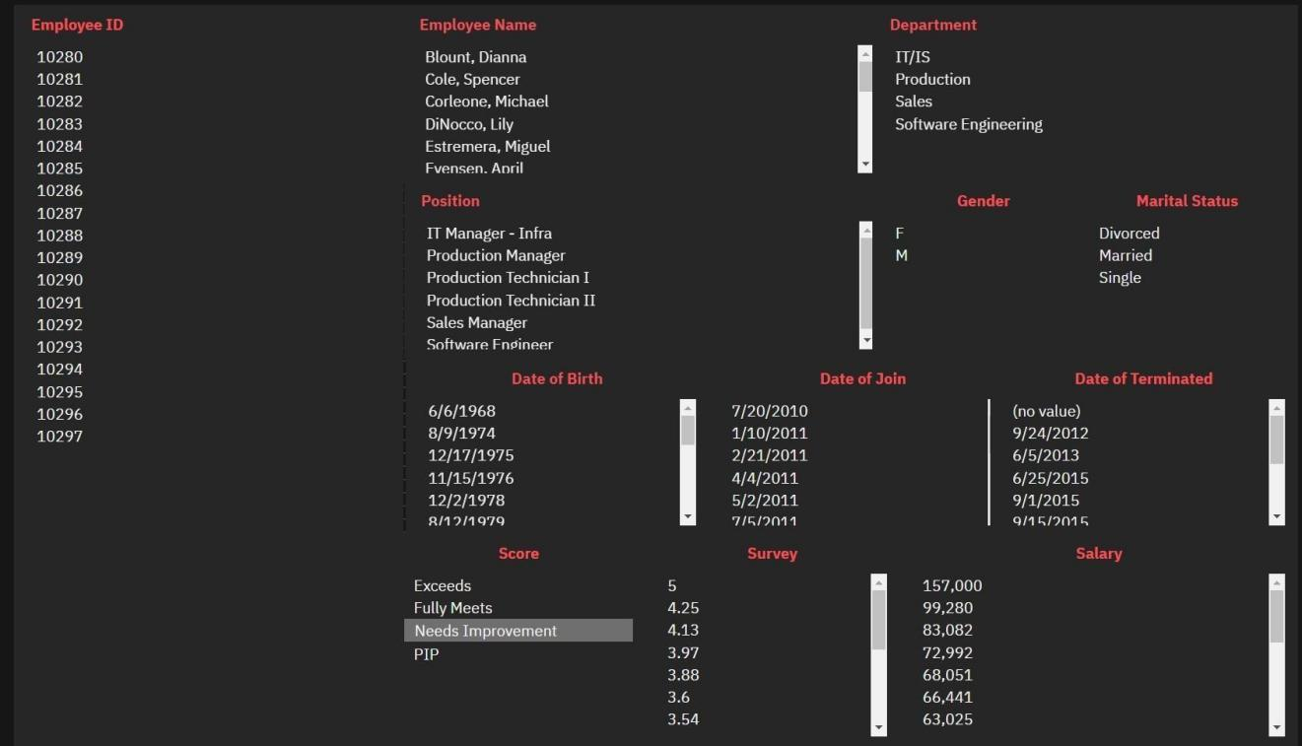

**Search with Survey Performance and Department**

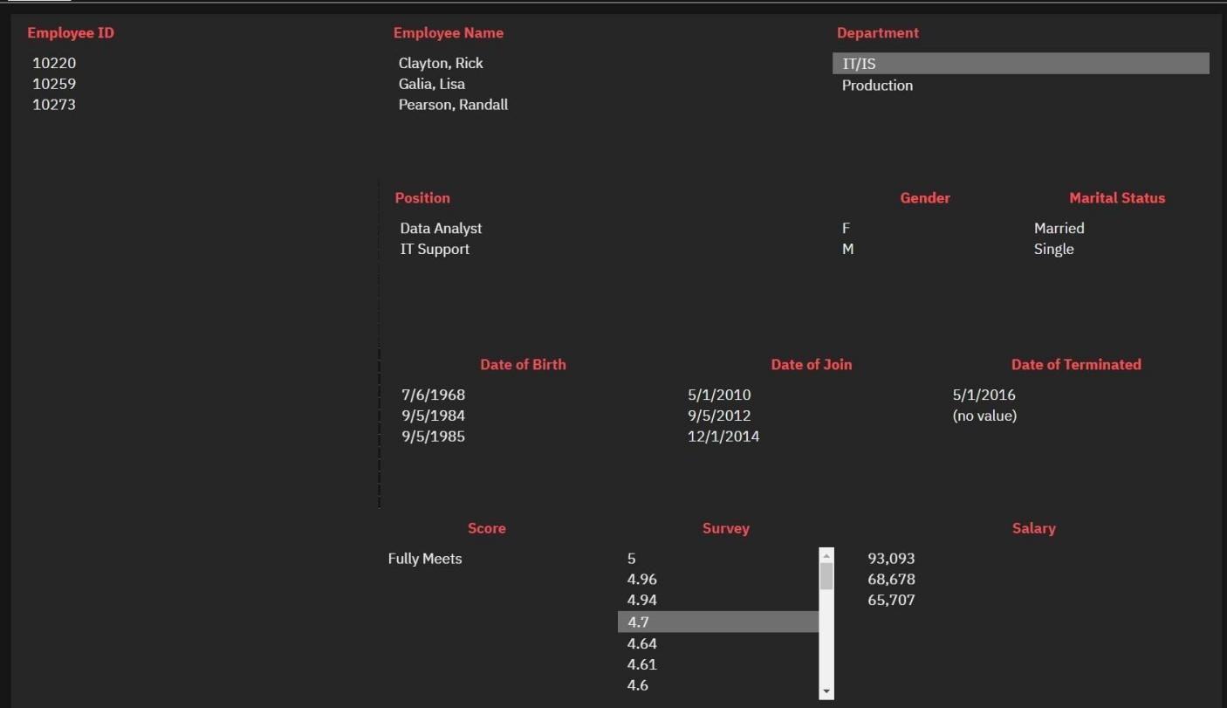

**Search with Multiple Attributes**

